

Price Announcement

TO: FSBP U.S. Valued Customers
Dear Firestone Building Products customers,
The roofing industry continues to operate within a challenged environment with demand outpacing supply. As a result, Firestone Building Products is implementing the following price increases:
Effective October 1, 2021:

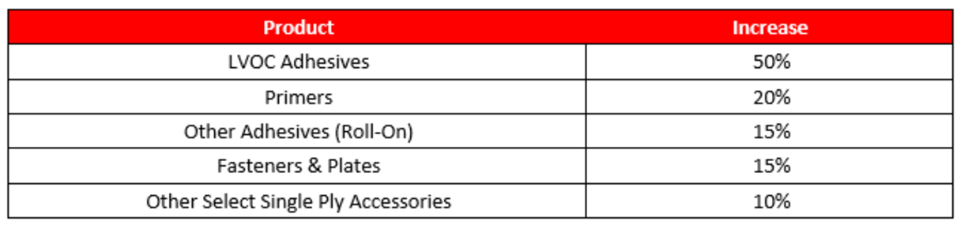

As a reminder, metal and all other category accessories will continue to be priced at the time of shipment.
Thank you for your continued support of Firestone Building Products.
If you have any questions regarding how this price adjustment will affect you, contact your local Firestone Sales Representative or Regional Business Manager .
Sincerely,



Jeff Boecker
Pricing Director
Firestone Building Products



